Chapter 10 - 18th Century Vocab

1. Anglomania- Abbie Buns

Anglomania is a french fad for things that are English. This word describes an intense interest in things English. Not only was it a deep admiration for English clothing, but also towards their traditions and manners.

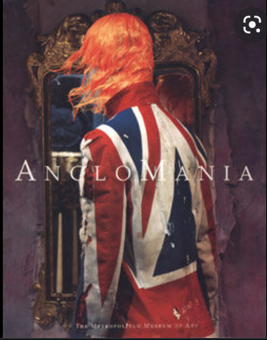

Source:

<https://www.merriam-webster.com/dictionary/Anglomania>

Book: 271

https://www.thefreedictionary.com/Anglomania

1. Banyan - Marisa Bone

Banyans were the garments that every gentleman in the 18th century loved. They were influenced by Persian and Asian clothing mimicking a kimono-like style. They were also called morning gowns or nightgowns. They were worn around the house as an informal coat before the day began and around the day's end. They were mainly made of cotton, linen, or silk.

[Source 1](https://www.geriwalton.com/banyans-garments-that-18th-century-gentlemen-loved/) [Source](http://www.larsdatter.com/18c/banyans.html) 2 Book Pg- 277

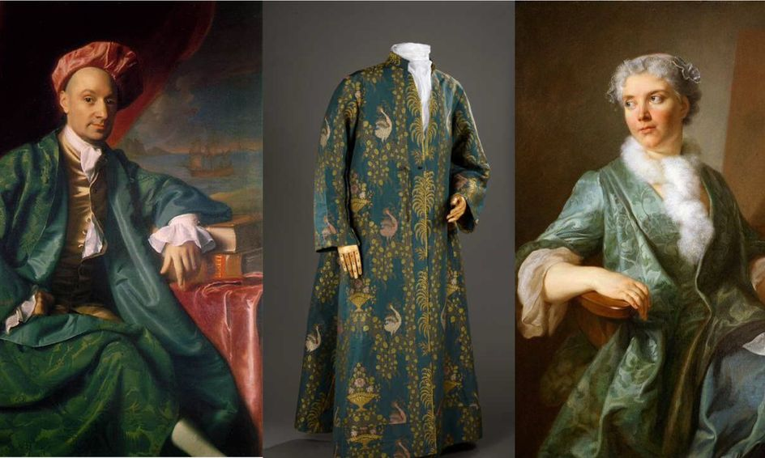

1. Bergere - Alex Clark

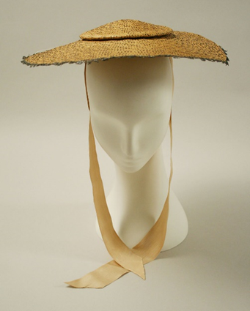

The bergère was a hat used outdoors that was composed of straw and generally had low crowns and wide brims incorporated into the hat. Along with being called a bergère, it was also called the shepherdess hat or milkmaid hat. The hat itself varied from the typical straw hat to more complex straw hats that incorporated designs into it.

Sources:

Survey of Historic Costume, Page 282

<https://en.wikipedia.org/wiki/Berg%C3%A8re_hat>

<https://www.metmuseum.org/art/collection/search/116849>

<https://thedreamstress.com/2013/03/terminology-what-is-a-bergere/>

1. Boot Cuffs - Aubrey Reidhead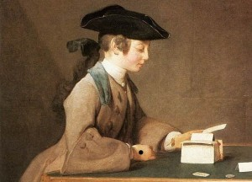

Boot Cuffs, contrary to their name, were attached cuffs for sleeves. They would either be completely closed around or would be open-backed (pg 276). This cuff was “frequently reaching to the elbow” and would blend to a normal sewn-on cuff. Deep boot cuffs had a speculated connection to thieving because they would be big enough to steal.

<https://handboundcostumes.co.uk/customer-care/customer-library/glossary-2/glossary/>

<https://fashionhistory.fitnyc.edu/1730-1739/>

1. Calash, Caleche - Jalissa Cloward

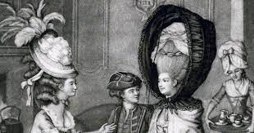The calash (or caleche) was a bonnet or hood that was made of several hoops that were covered with fabric. The hoops allowed the calash to stand tall in order to cover the wearer’s hairstyle. The hood was also collapsible and could be pulled up and down. It was named after a part of a french carriage.

*Survey of Historic Costume* pg. 284

<https://www.geriwalton.com/the-calash-bonnet/>

<https://www.metmuseum.org/art/collection/search/156795>

1. Caracao- Anna Ament

I saw numerous different spellings for this, but I will use the one found in the book. According to the book, the Caracao was "a long, fitted jacket (284)." These were typically worn as an accessory with dresses and skirts and were often made to match. The Caracao is not just a typical jacket, mainly because of its fitted shape. The length of the Caracao depended on the preference of the person who would wear it. Sometimes, the length also depended on the formality of the occasion for which the garment was intended. Often times it was made of luxurious fabric such as silk. 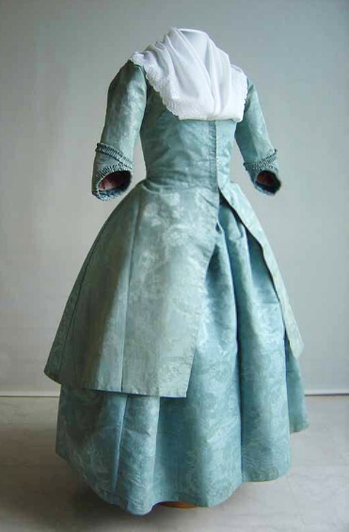

Sources:

<https://fashionhistory.fitnyc.edu/caraco/>

<https://libertabooks.com/costume/historical-costume-1780s-caraco/>

1. Casaquin- Kya Boyd 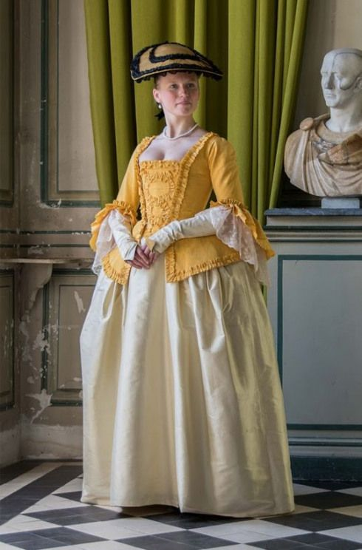

Casaquin is a short length closely fitted coat worn by middle and upper class women during the 18th century. Middle/ working class women wear these jackets for more practical reasons while upper class women wear casaquin’s to social or ceremonious events. This style became popular in both France and Italy. Casaquin are made from linen then covered by embroidery. They are usually decorated and covered by silk or lace. This design was influenced by religious beliefs or events.

Sources:

<https://en.m.wikipedia.org/wiki/Casaquin> <https://blog.americanduchess.com/2010/10/what-is-difference-between-caraco-and.html>

The book “Survey of Historic Costume”

1. Catogan- jamie rakes

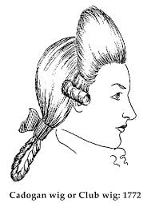

The catogan, cadogan, or club wig, was worn by males during the 18th century. It was named after general Cadogan. This wig was tied loosely in the back with a ribbon to create a bob like effect in the middle of the pony tail.

It was mostly popular for the ”macaronis” who favored the bigger catogans and was worn mostly starting in 1760s.

<http://www.theweebsite.com/18cgarb/1750.html>

<http://thisisversaillesmadame.blogspot.com/2015/01/the-gentlemans-hair-guide.html?m=1>

Textbook pg 200

1. Chapeau Bras - Debbi Wright

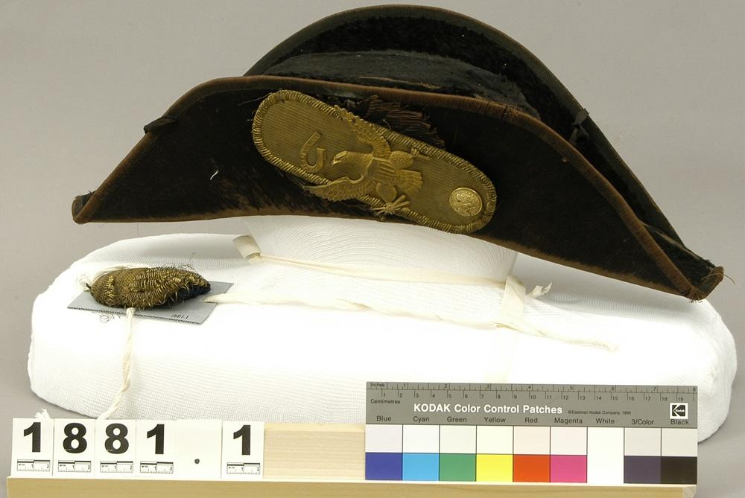

<https://kcts9.pbslearningmedia.org/resource/ket-history-civilwar10/cassius-m-clays-chapeau-bras/>

1. Chemise a la Reine - Abby Fluckiger

The chemise a la reine was a style associated with Queen Marie Antoinette (hence the name, “reine” meaning “queen”). It was a long white or colored gown with flounces at the neckline, cuffs, and hem, ties along the sleeves, and tied with a wide colored sash at the waist. At first, it was a scandalous style, since it bore so much resemblance to the undergarment chemise, with its light flowy fabric, gathered neckline, and softer structure than most styles of the day. It caught on quickly anyway in both France and England and remained in popularity for years. Its influence can still be seen decades later, well into the middle of the 19th century.

​​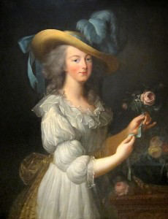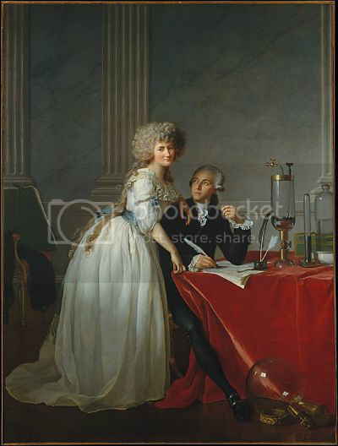

Sources:

Textbook page 289

<http://demodecouture.com/on-the-origins-of-the-chemise-a-la-reine/>

<http://www.thefashionhistorian.com/2012/03/chemise-la-reine.html>

1. Clog - Jensen Stenquist

The clog has a reinforced leather sole with mid-step support and ribbons to connect the clog to the shoe across the top of the foot. A shoe like this was made specifically for the customer, and represented a significant investment for the purchaser. Because of this, many shoes were paired with some sort of protection worn for the sole of the shoe, allowing it to become a flat to walk over cobblestones and protect the nicer upper from the mud and muck of 18th century streets. The footwear worn by Georgian ladies is among the most elegant and dainty in the history of female shoes. Keeping such shoes clean in the streets of London must have been quite a challenge.

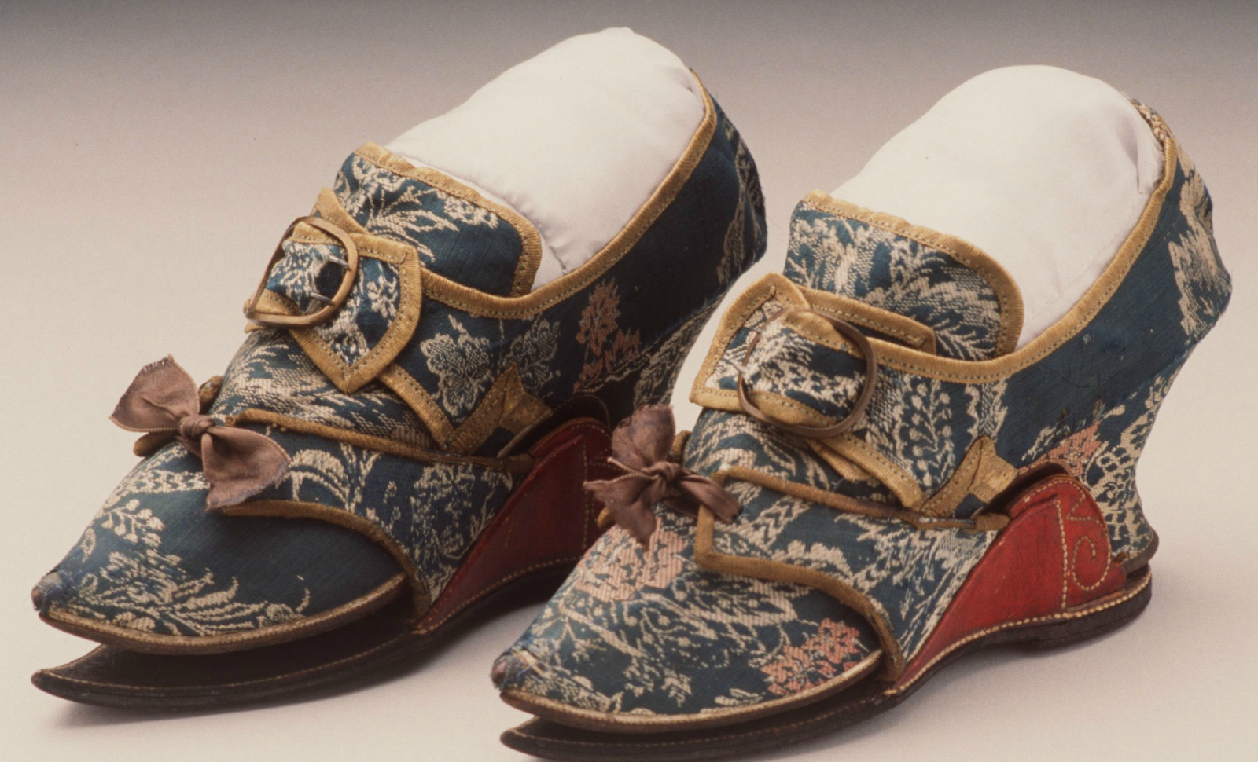

<https://americanhistory.si.edu/collections/search/object/nmah_364643>

<https://twonerdyhistorygirls.blogspot.com/2015/03/clogs-for-keeping-18th-c-ladys-shoes.html>

The book

1. Club Wig - Irelynd Preece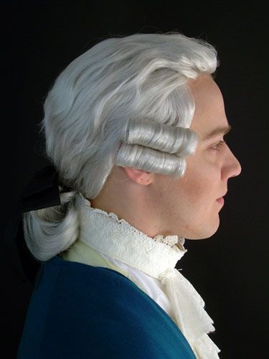

Club wigs were wigs that had queues that were doubled up on themselves and tied at the middle of the head to form a loop of hair. These wigs were made of human hair, horsehair, or goat hair. The reason for wigs was because they were seen as an attractive alternative to coping with a lice infestation on your own scalp. Wigs were also a major status symbol in the second half of the 18th century.

Sources:

Textbook page 276

<https://www.headcovers.com/blog/why-did-men-wear-white-wigs/>

<https://www.battlefields.org/learn/head-tilting-history/rise-and-fall-powdered-wig>

1. Engageantes- Ida Johnson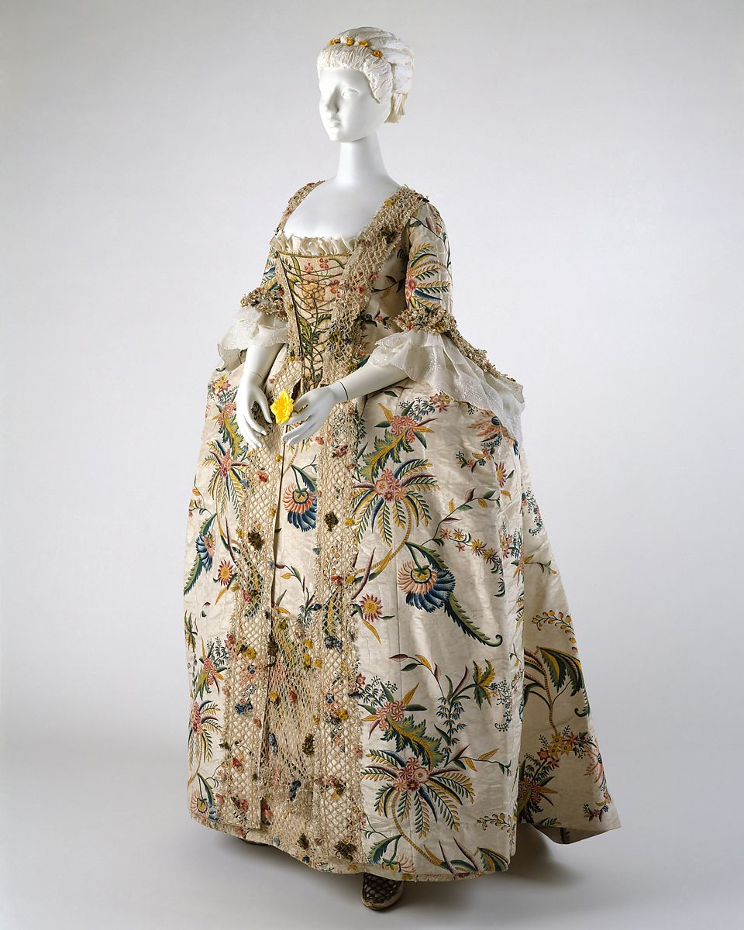

Sleeves ending below the elbow, finishing in one or more ruffles. Usually lace. (282) <https://www.encyclopedia.com/fashion/encyclopedias-almanacs-transcripts-and-maps/engageantes> <https://artsandculture.google.com/story/women-s-fashion-in-the-18th-century-kyoto-costume-institute/yQVxozIBUz__KQ?hl=en>

1. Eschelles: Elizabeth Nathan

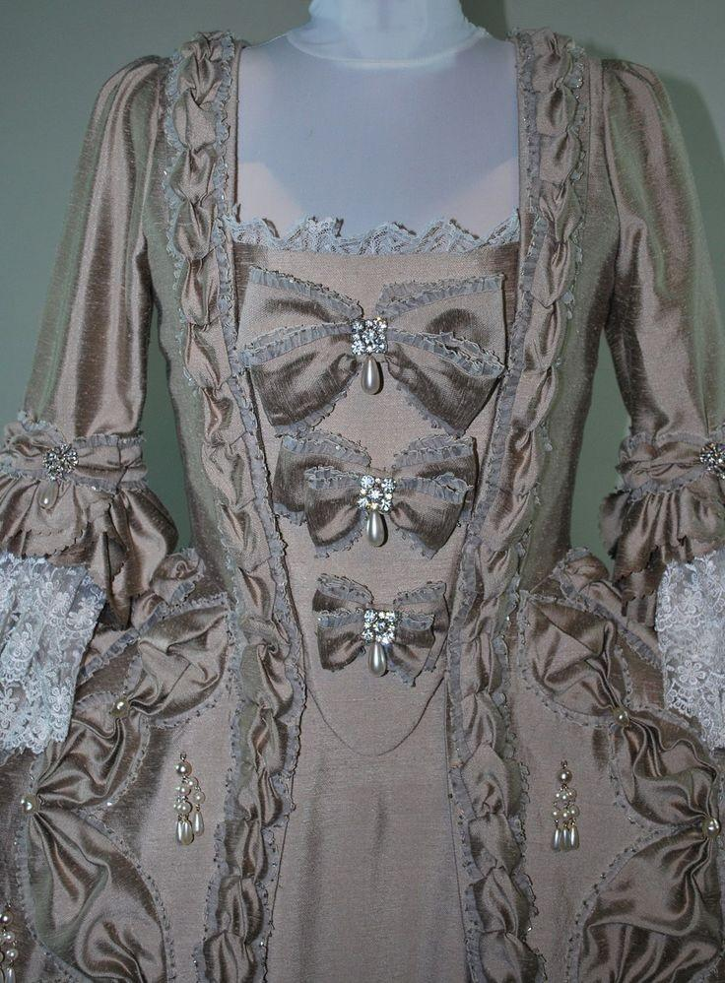

**Heavily decorated stomachers became especially popular in the eighteenth century. One of the most popular styles of that century was the échelle or eschelle, a series of bows tied down the front of the stomach, decreasing in size from the neck to the waist.**

[**https://fashionhistory.fitnyc.edu/echelle/**](https://fashionhistory.fitnyc.edu/echelle/)

[**https://books.google.com**](https://books.google.com/books?id=CbOI4TCcnbQC&pg=PA109&lpg=PA109&dq=eschelle+meaning+fashion&source=bl&ots=afvqnqLoEA&sig=ACfU3U2V41w5S5RWfxNvOFRjbOBKxAl5Zg&hl=en&sa=X&ved=2ahUKEwic3v2K8v_1AhW_GjQIHUllBdcQ6AF6BAg5EAM) **[›](https://books.google.com/books?id=CbOI4TCcnbQC&pg=PA109&lpg=PA109&dq=eschelle+meaning+fashion&source=bl&ots=afvqnqLoEA&sig=ACfU3U2V41w5S5RWfxNvOFRjbOBKxAl5Zg&hl=en&sa=X&ved=2ahUKEwic3v2K8v_1AhW_GjQIHUllBdcQ6AF6BAg5EAM)**

1. Fall
2. False Rumps- Jessica Fraser

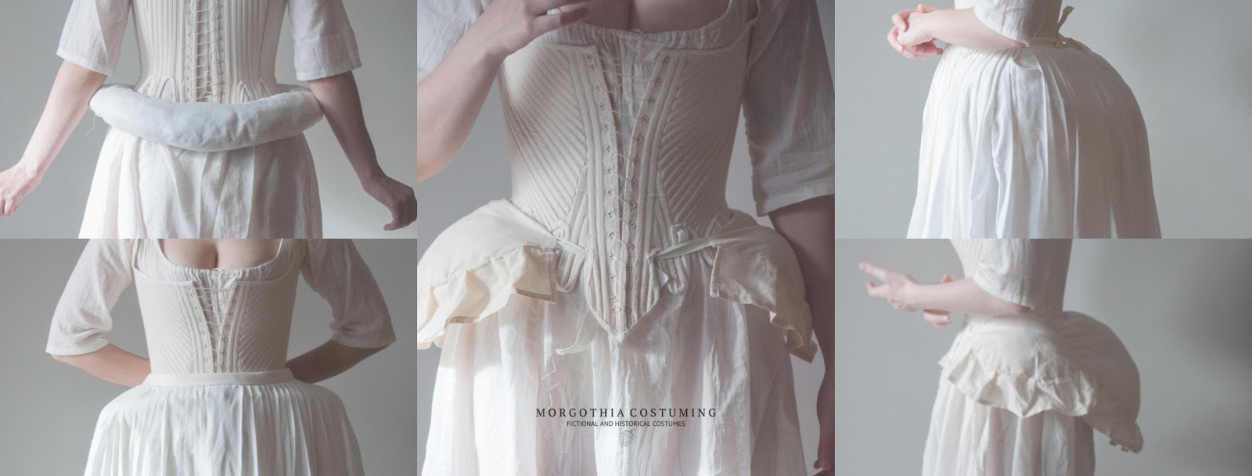

False rumps were placed at the waist and in pockets of women's dresses to give more volume to their hips and bums. It also made the waist delicate looking and gave them better posture. While watching the videos, I can't imagine how long it took to lace the stays and get ready in the morning. I understand it made them look more thin, but was it worth all the time putting into it?

Sources:

The Book

<https://georgianera.wordpress.com/2018/03/01/false-rumps/>

[(Links to an external site.)](https://georgianera.wordpress.com/2018/03/01/false-rumps/)

<https://fabricnfiction.com/tag/18th-century-false-rump/>

1. Fashion Babies- Lauren Shumway

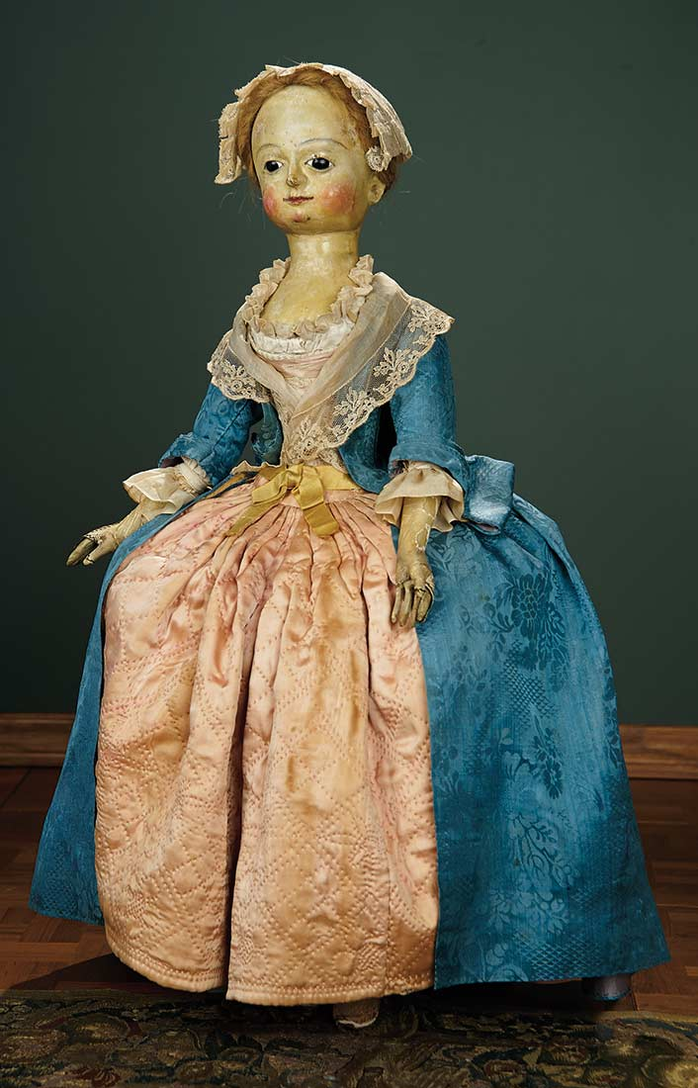

The fashion babies also known as pandoras or poupées de mode, these dolls were used as a way to show off the latest fashion in shop windows. The dolls also would show the shape of garments in a better way than fashion plates. The origin of the fashion babies are disposed of in Italy during the Renaissance or early 14th century France. The dolls were made out of wood, human hair, and sometimes glasses eyes would be used. The dolls fell out of favor in France after Napoleon banned them because he thought the dolls were being used to send secret messages. In the modern day the close thing to fashion babies is the fashion dolls.

The Book

<https://costumesociety.org.uk/blog/post/walk-walk-fashion-baby-18th-century-fashion-dolls>

https://en.wikipedia.org/wiki/Fashion_doll#Before_19th_century

1. Foretop
2. Frock Coat - Amanda Taylor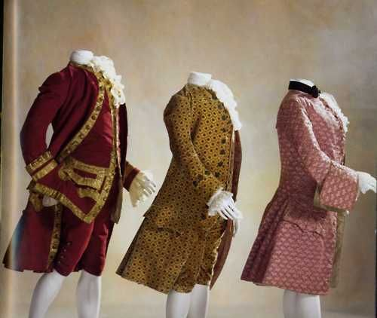

During this era a gentleman would not be fully dressed without a coat like this. The finest materials wouldn’t have been affordable to commoners, but everyone wore a coat so they would use the most expensive material they could afford. Frock coats of this time were typically knee length with a button up front, collar, and lapel. Often the Lapel was cut of a different fabric making it stand out from the rest of the jacket. Usually it was worn with gray pinstripe style pants.

<https://reconstructinghistory.com/blogs/victorian/the-history-of-the-frock-coat>

<https://en.wikipedia.org/wiki/Frock_coat>

Textbook page 277

<https://www.samsonhistorical.com/collections/coats-frocks>

1. Gaiters: Lexie Pincock

They were a separate protective covering that went from the shoe up to the knee. They were meant to protect the legs. Also considered boots without the soles.

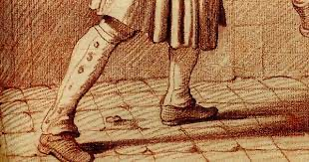

Sources:

Pg. 277

<http://www.katetattersall.com/spatterdashes-gaiters-spats-for-protection-warmth-and-disguise/>

<http://www.larsdatter.com/18c/gaiters-spatterdashes.html>

1. Greatcoat
2. Hedgehog hairstyle- Brittany Pocock

Had hair curling around the face with long locks in the back. The curls were easily done and wildly styled. It isn’t surprising that their hair was so over the top because that is how their clothes were back then two. Some things to note about this hair style are. It is wider than it is tall. The poofy curls covered the ears. They had more thick sculpted rolls hanging down the back.

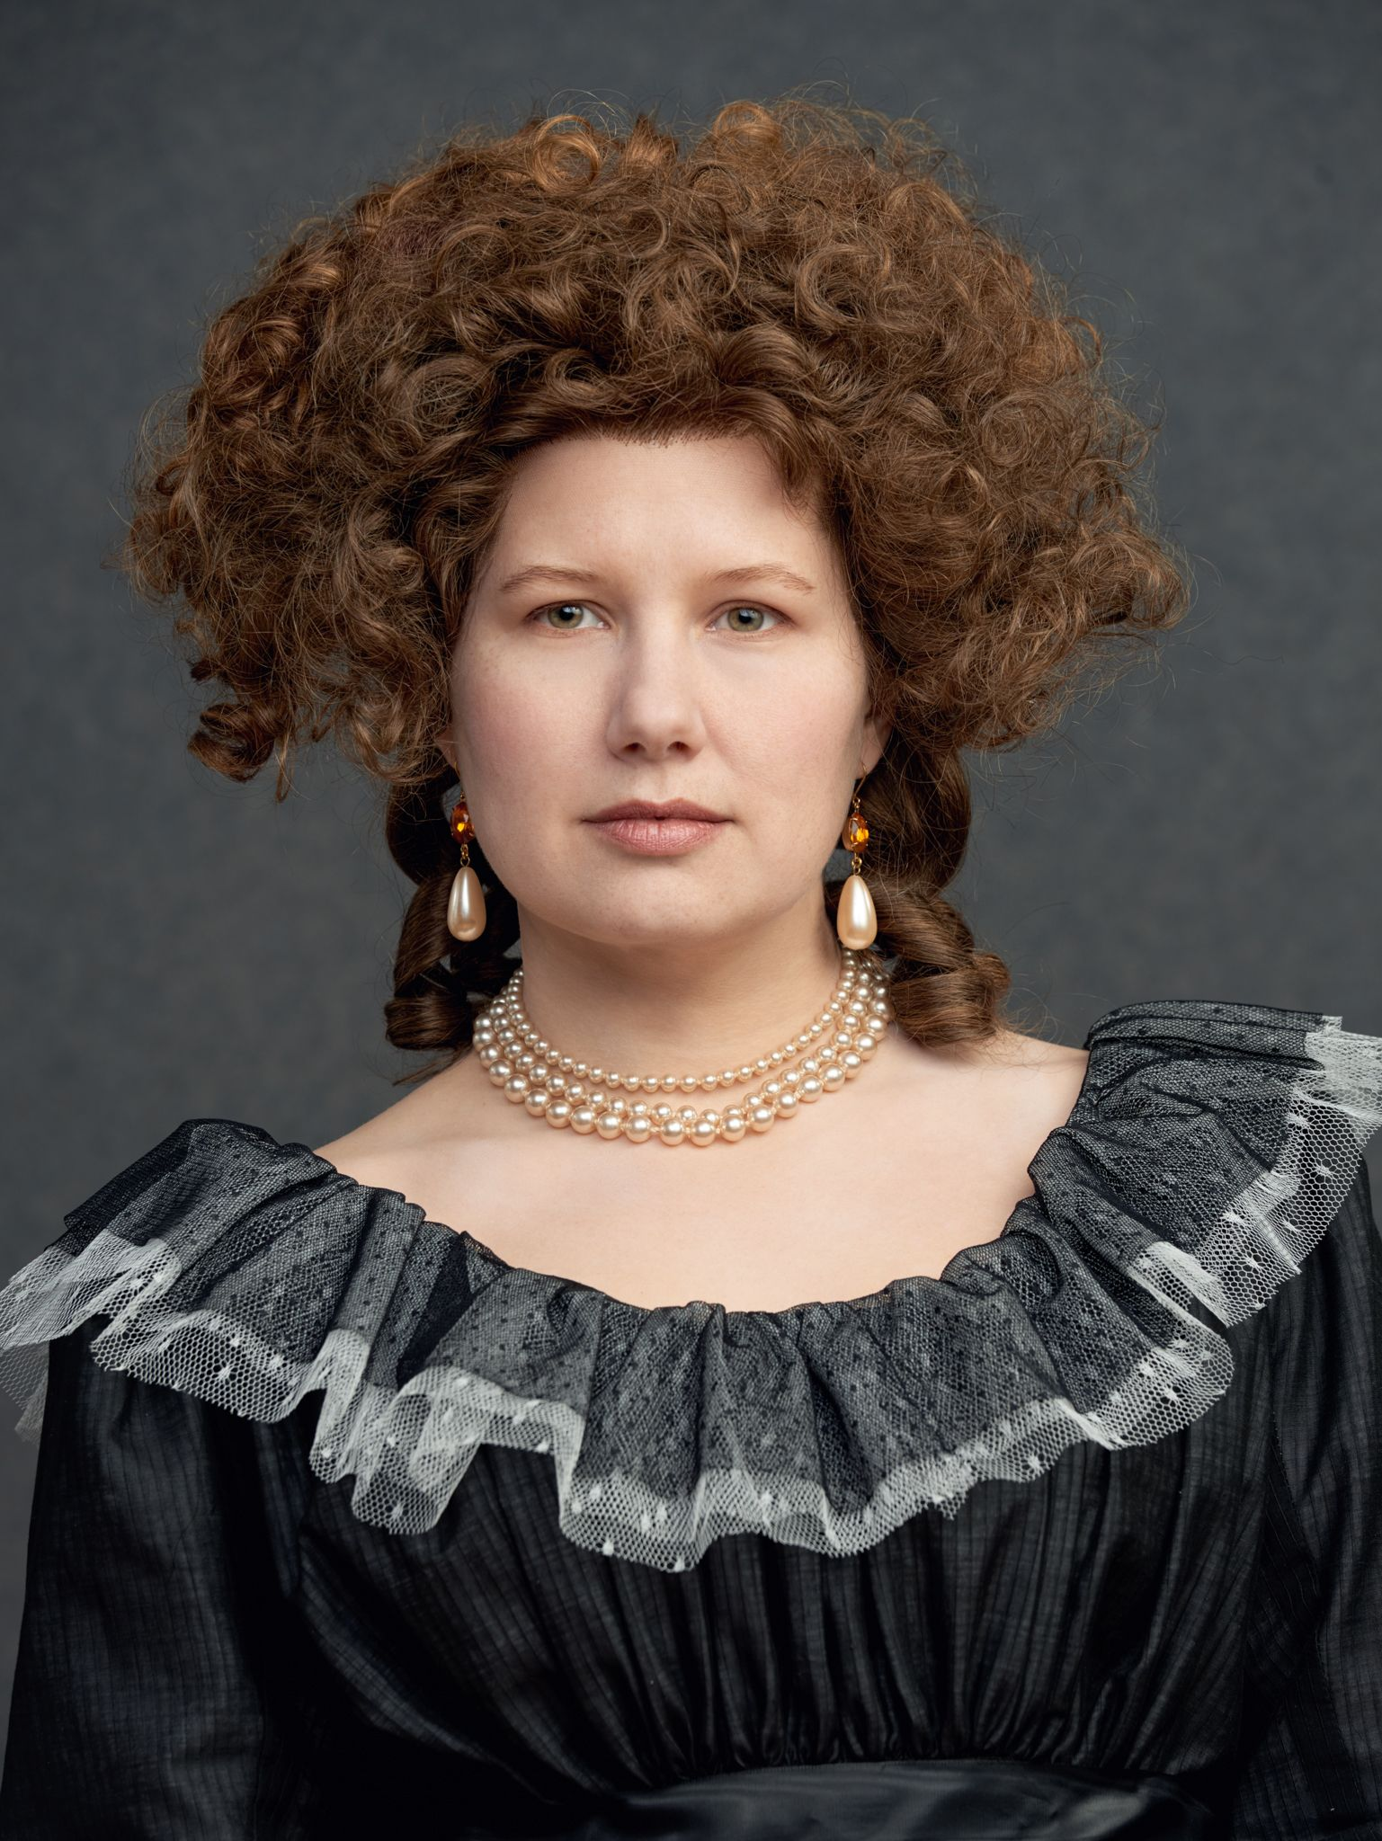

Book

<https://blog.americanduchess.com/2012/08/v229-analyzing-hedgehog-hairstyles.html>

<https://my18thcenturysource.tumblr.com/post/131093073387/hairstyle-hedgehog>

1. Hoops
2. Innocente
3. Jumps
4. Macaroni- Abigail Storrer

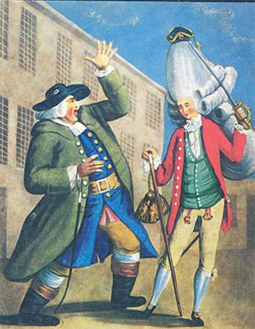

Macaroni was a reference to a club of usually young men from England in the second half of the eighteenth century. These men liked to dress very fashionably and found inspiration from the countries across the pond, mainly France and Italy. These men did not just dress fashionably but extravagantly, using bright silks, lace, and wearing very small hats on top of their wigs.

Tortora, P. G., & Eubank, K. (2010). *Survey of historic costume: A history of western dress*. Fairchild.

<https://www.historytoday.com/miscellanies/meet-macaronis>

<https://www.messynessychic.com/2021/10/28/the-macaroni-club-fashion-historys-forgotten-drag-subculture/>

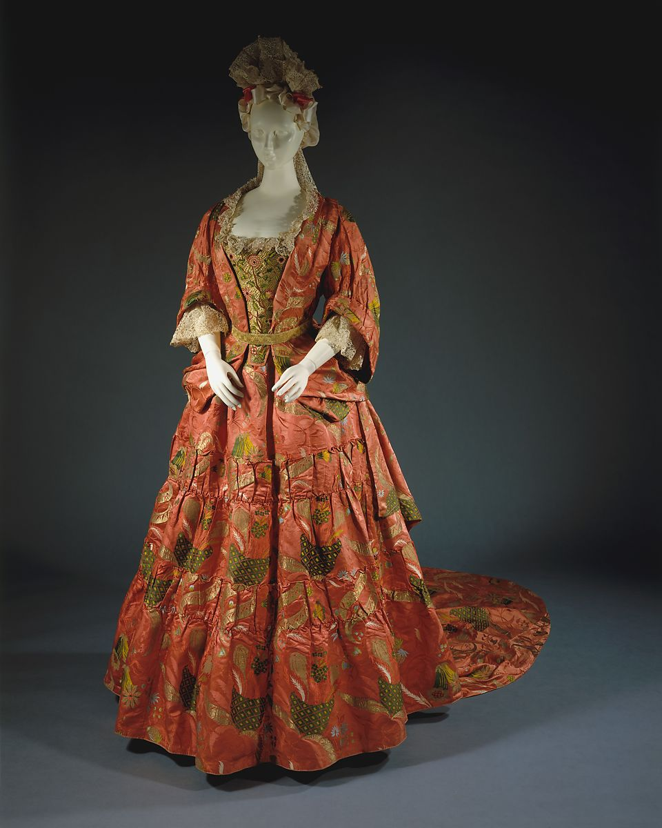

1. Mantua-style gown- Samantha Hooper

The mantua-style gown was a style of dress cut all from one length of fabric, rather than a separate top and skirt being cut. It was looser and more casual than other gowns, but still worn over an underskirt and corset. Later styles included stomachers. The bodice is jacket-like, and the skirt is often bustled in the back.

<https://www.metmuseum.org/art/collection/search/81809>

https://fashionhistory.fitnyc.edu/mantua/

1. Paniers - Kimberly Tesam Moita

Paniers were hoops that were used in undergarments or as undergarments that created shape in women’s clothing. They were made of wicker, which in French means basket, but were made with various materials like whalebone and metal. The paniers were pretty wide, so it made the dress have bumps on each hip, making it hard for women to move through doorways. The paniers were usually tied or held together in a frame with tapes so it could be tied around a woman’s waist and create shape under clothes.

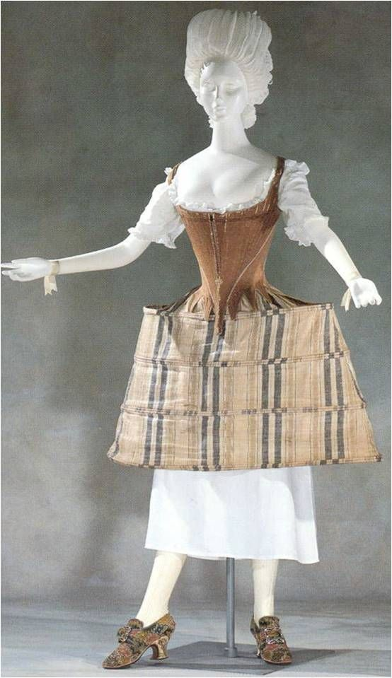

<https://historydaily.org/panniers>

<https://fashionhistory.fitnyc.edu/panniers/>

<https://www.metmuseum.org/toah/hd/18sil/hd_18sil.htm>

1. Pet-en-l'air- Andrea Lazaro Hernandez

This style was more popular in England than in France. It consisted on an open “jacket” that showed the petticoat. The pet-en-l’air was considered an undressed garment, meaning that was worn only at home, but it was formal enough to be worn in front of guests. Pet-en-l’air were waist length.

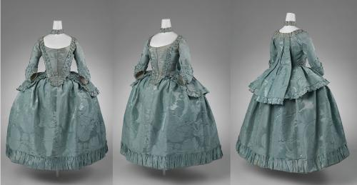

1. Polonaise
2. Queue
3. Redingote
4. Robe a la Francaise- Bailey Pinder

This was one of the styles that replaced the sacque. The robe à la française was derived from the loose negligee sacque dress of the earlier part of the century. It was worn over a bodice decorated with a stomacher and outfitted with hoops or paniers that supported its skirt. The gown was parted in the middle to form a V-shaped opening that allowed contrasting or identical underskirts to show through, thus creating an impression of an abundance of cloth and material.

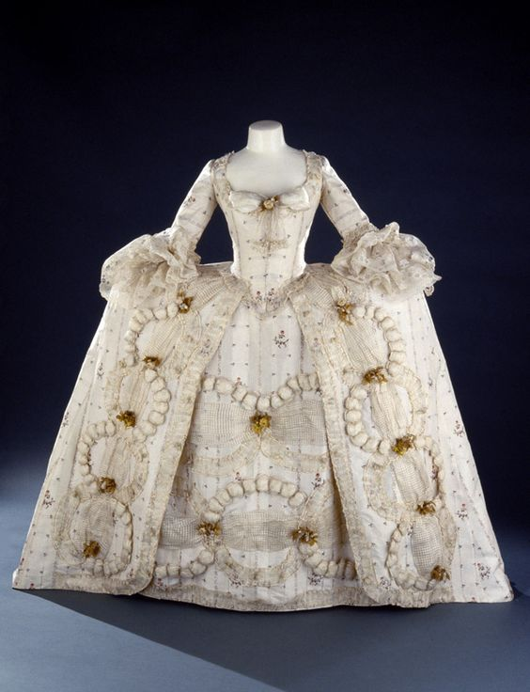

<https://fashionhistory.fitnyc.edu/robe-a-la-francaise/>

<https://www.metmuseum.org/art/collection/search/159485>

The book, page 281

1. Robe a Anglaise
2. Robe Battante
3. Robe Volante
4. Round Gown- Lena Kawakami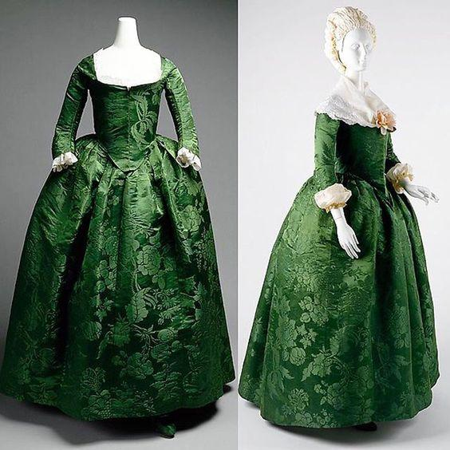 round gowns had a front-closing bodice with no stomacher. It’s a gown that closed all the way down the front. Only the back of the bodice was attached to the skirt and the sides had slits so people could get into the dress. Sources I used were the the book and these websites <https://ateliernostalgia.wordpress.com/2018/02/02/round-gown-inspiration/amp/> http://www.larsdatter.com/18c/round-gowns.html
5. Sacque
6. Shepherdess Hat- Savannah Tanner

The shepherdess hats were worn outside. They tied either under or over the brim. The shepherdess hat was also called the bergere or milkmaid hat. The crown of the hat was very low, almost flat. The hat could be tied under the chin with a ribbon, or behind the head. The hats were decorated with ribbons and flowers, and occasionally silk for higher class customers. 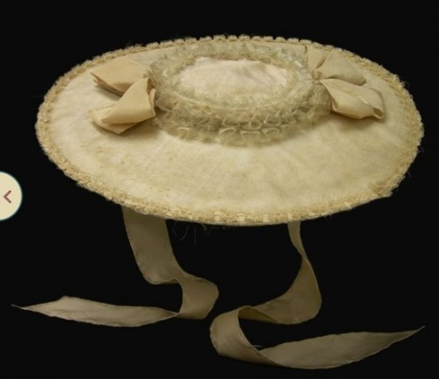

Pg 282

http://nationalclothing.org/855-bergere-hat-%E2%80%93-18th-century-straw-hat-worn-by-milkmaids-and-queens-alike.html

https://thedreamstress.com/2013/03/terminology-what-is-a-bergere/

1. Short Gown- **Ryann Becker**

This garment was typical of the working class or rural areas and therefore made for convenience. They were also worn by enslaved people. A short gown was a jacket or over blouse that they wore over the chemise and ended around the hip area before the petticoat skirt. It looks similar to a modern day blouse. They were popular in the warm weather. 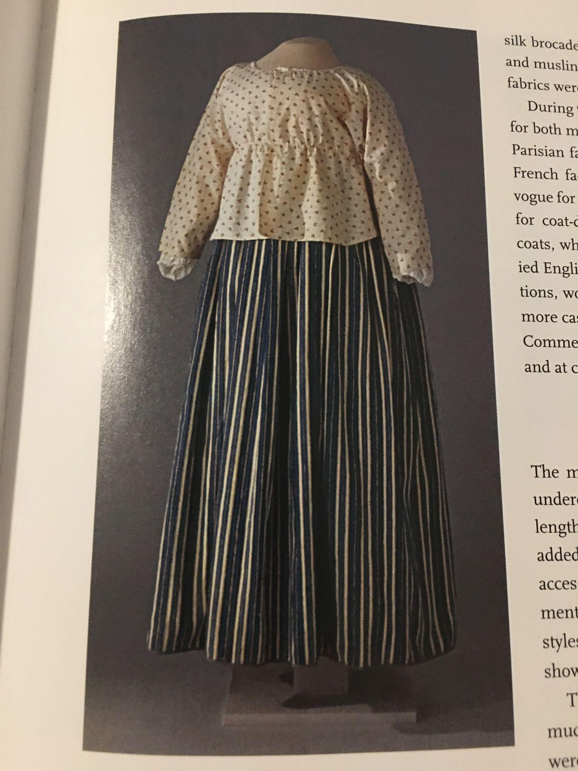

Textbook page 270 and 271

<http://www.larsdatter.com/18c/shortgowns.html>

<https://recreatinghistoryblog.com/2019/01/12/an-18th-century-shortgown/>

1. Skeleton Suit - Hannah Ferreira

The skeleton suit came about as children’s clothing began to change. “In 1780, boys older than 7 or 8 wore long straight trousers, a white shirt with a wide collar that finished in a ruffled edge, and, over the shirt, a jacket that was either a shorter, simplified version of those of adults or cut to the waist and double-breasted” (289). This was known to be one of the earliest fashions for children. 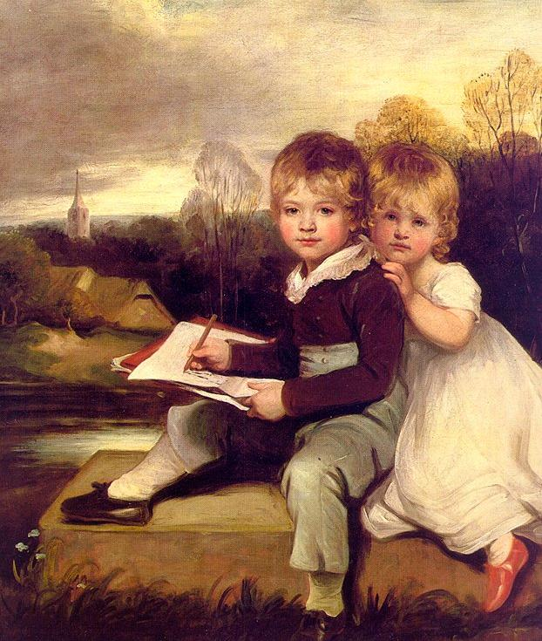

<https://janeaustensworld.com/2009/08/17/the-well-dressed-regency-boy-wore-a-skeleton-suit/>

<https://fashionhistory.fitnyc.edu/skeleton-suit/>

Book

1. Smock Frock- Claire Moore -An over garment that is traditionally worn by rural workers/ farmers. That is how it gets its nickname “farmers frock”. It acted as a layer of protective garments.

<https://en.m.wikipedia.org/wiki/Smock-frock>

<http://www.larsdatter.com/18c/smocks.html>

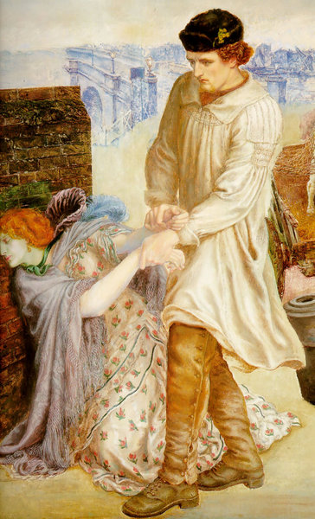

1. Smocking- Zaya Weight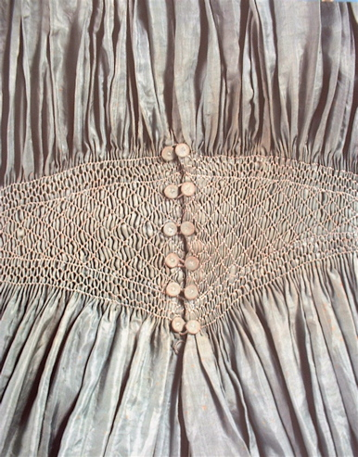

Smocking is a type of embroidery that was frequently used to decorate smock frocks. It was used as a decorative way to gather fabric & gave it the ability to stretch. It was often used in cuffs, bodices, and necklines in garments. Its stretch made it useful for a bit of fittedness without the use of buttons. Also i think it’s pretty but that’s not really relevant.

**Sources:**

Survey of Historical Costume- page 274

<https://janeausten.co.uk/blogs/uncategorized/smocking-a-stitch-time>

<https://www.mrxstitch.com/smocking/>

1. Spatterdashers, Spats
2. Steinkirk - Jocelyn Munoz

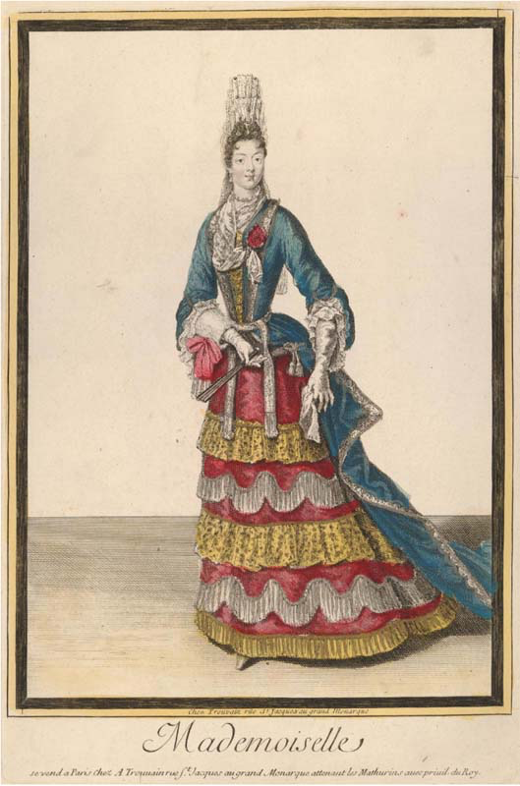

The Steinkirk was a caravat that was usually pulled through a buttonhole or left with it’s ends hanging or very loosely twisted together, it was worn by both men and women in the 18th century. It was widely believed to have originated during the Battle of Steenkerque by the soldiers but there is evidence that it originated several years before that.

<https://turnbullandasser.com/blogs/off-the-cuff/off-the-cuff-history-of-neckwear>

<https://fashionhistory.fitnyc.edu/1690-1699/>

Tortora, P. G., & Marcketti, S. B. (2021). In Survey of historic costume. essay, Fairchild Books.

1. Tête de Mouton (Hairstyle) - Savannah Jeppson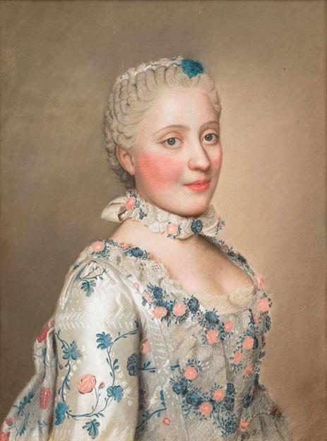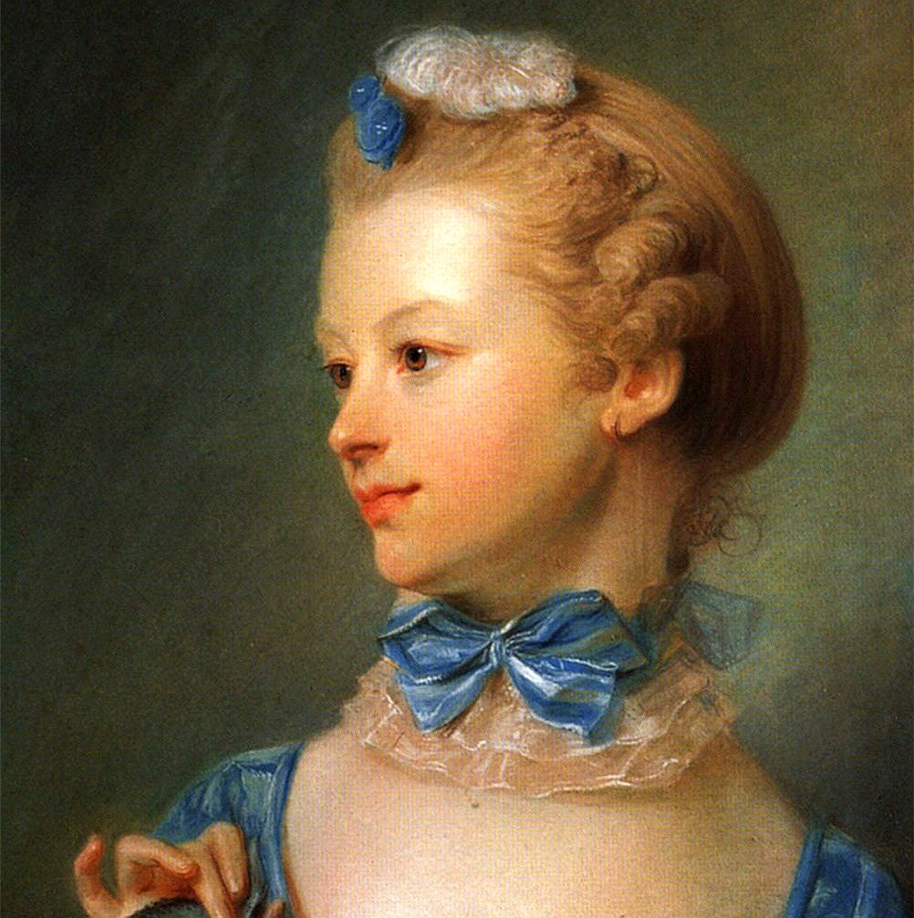

The Tete de Mouton was a hairstyle that was achieved by either combing the hair back from the face into a bun at the top of the head or plait, or by using tight, close curls. The direct translation of Tete de Mouton is “sheeps head”. It was an elaborate hairstyle mostly worn at courts. It was dusted/powdered and most of the time, accessorized.

Sources: The Book

<http://thisisversaillesmadame.blogspot.com/2014/11/tete-de-mouton.html>

https://www.pinterest.com/pin/352406739577916711/

1. Toupee-Marisol Dejesus

A toupee is a small hairpiece that covers a bald spot. Women and men began to comb their hair straight back from the forehand to create a natural hairline. The toupee began in the 1730s and is usually worn by men more than women. In English toupee is called foretop.

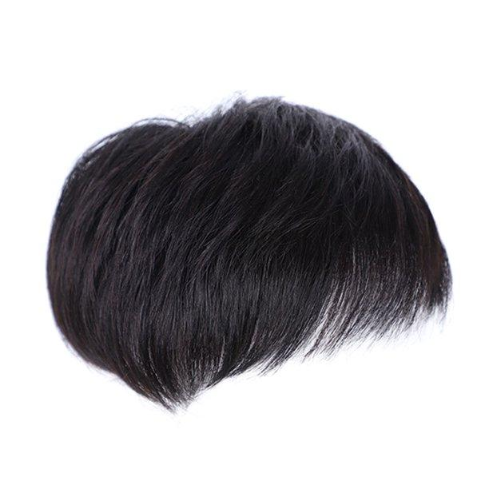

Source:

Book:276

<https://www.britannica.com/art/toupee>

<https://www.superhairpieces.com/toupee-wig-hair-system-blog/what-is-the-difference-between-a-wig-and-a-toupee/>

1. Under Petticoat: MADISON FROST

Petticoats were used and worn under clothing, worn by itself, or used to layer to create a more “poofy” effect. However, they were mostly worn under skirts to create a more defined shape. It was said that cotton was the fabric used for the construction of the petticoat.

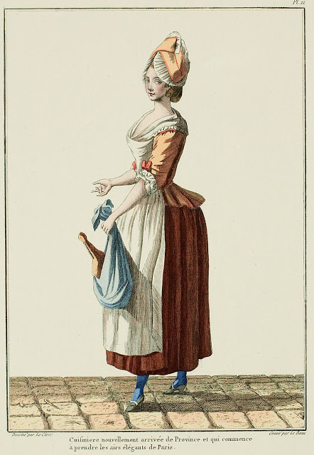

Tortora, P. G., & Marcketti, S. B. (2021). In Survey of historic costume. essay, Fairchild Books.